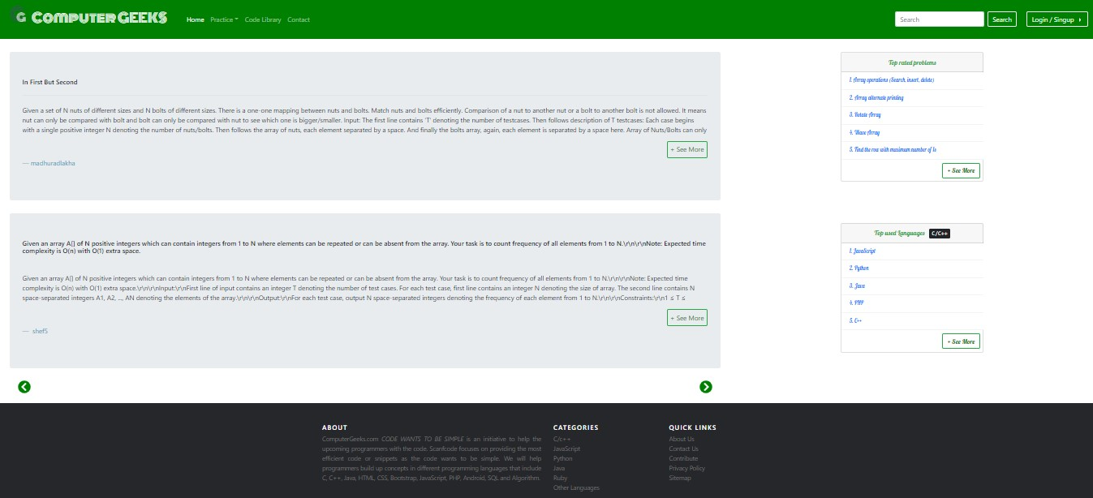

First at the title under the title tag Computer geeks is written .  
Then the computer geeks logo is also set under the icon tag inside the head element in html.  
The link of the stylesheet is attached. we are taking one stylesheet only named Style1.css.  
So now we have three elements in our foulder . One is the icon,the html code and the stylesheet.  
  
Properties and contents in different files of html:  
  
html body code :  the html body bg codes contains a image . The whole body is divided into three  
main parts:  
1) The header part  
2) The Body part  
3) The footer part  
  
1) The header part is divided by a div id header tag .  
 under the header division two more divisions are created the main computer geeks ico division and the navigation links division.  
Inside the computer geeks logo division an image source is placed . The image tag will contain the link of the image.  
  
Coming to the navigation tag .  
the navigation tags will be inside the navigation tag inside the division with the div id = "nav" . the nav will contain ol with lis Practice   
li Code library Li contact and li login .the ol is ended here   
  
2)The body part is 3 divisions : the division with div id ="problems" consists of the problms which are coming from the server.   
the next division will consists of division  id "top rated problems". and it will contain top rated programs.  
the third dividion will consists of div id  = "top rated languages" and it will display all the top rated languages which are   
prefffered by the coders all over the world.  
  
3 ) The footer part will consists of two only on div of navigation buttons which will manipulate next pages of problems in the body!

Advantages of competitive programming

In competitive programming we design algorithm for a solution of a problem and code the solution in our favorite programing language.

In every year a multi-tiered programming contest is organised by ACM-ICPC(Association for computing machinery-international collegiate programming contest).

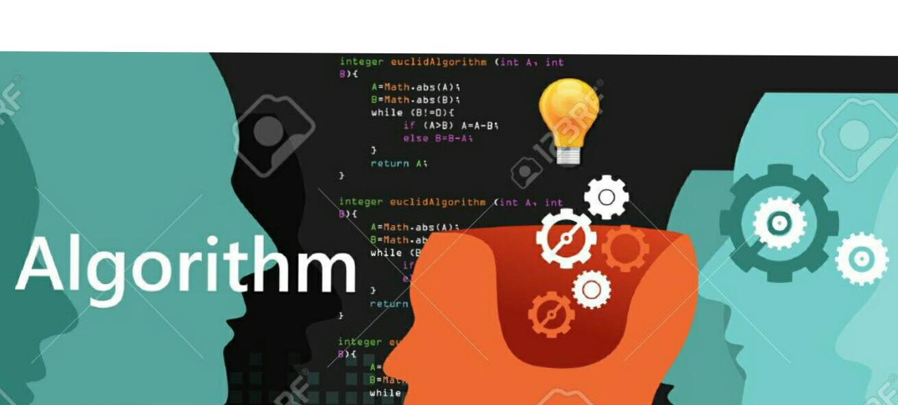Competitive programming enhance problem-solving skills.

Competitive programming is a brain sport which tests our basic to advanced problem solving skills.

Competitive programming teaches us to find the easiest solution in a quickest possible way.

It enhances our problem solving skill.

Willingness to accept the “failure” increases

helps us to learn determination and how to fight until the problem is solved.

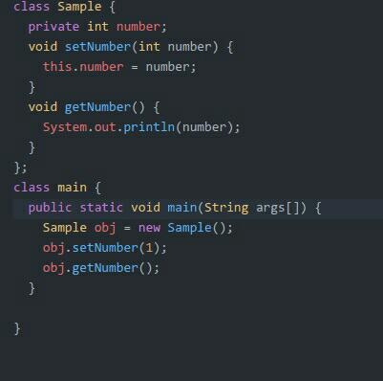✳ Competitive programming boost the programmer to write cleaner and better code.

 In many Competitive events required team participation. Individual members of a team that can be from various dimensions like age, nationality etc. So we can learn how to work in team through Competitive events.Some famous Competitive programming 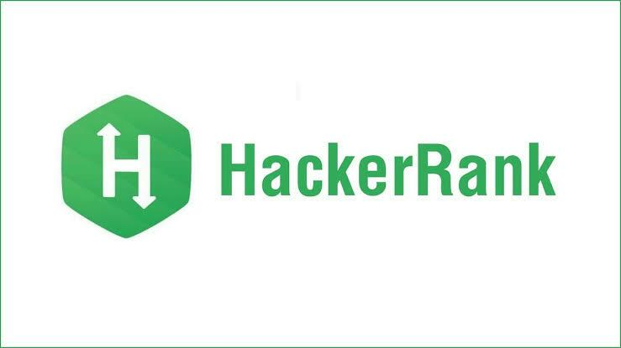platforms